**Ministry of Science of the Republic of Kazakhstan**

**Astana IT University**

**Introduction to Programming 2**

**Python**

**Report**

**Week 3.**

**Student name**

**ALIKHAN KENZHEBEK**

**Astana**

**2024**

**Report Example:**

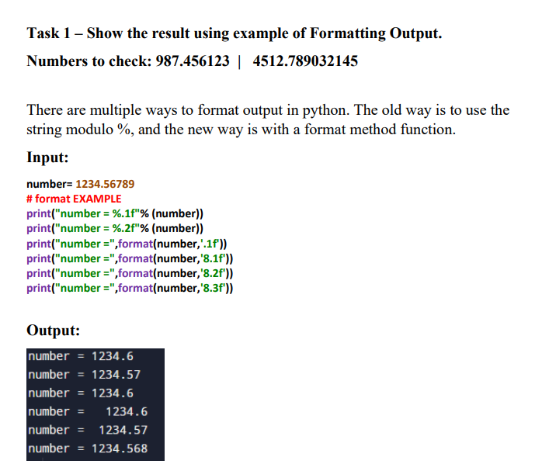

Answer

number = 1234.56789   
  
# format EXAMPLE   
print("number = %.1f" % (number))   
print("number = %.2f" % (number))   
print("number =", format(number, '.1f'))   
print("number =", format(number, '8.1f'))   
print("number =", format(number, '8.2f'))   
print("number =", format(number, '8.3f'))

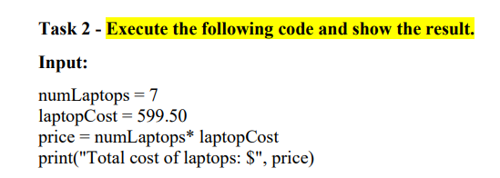

Answer

numLaptops = 7   
laptopCost = 599.50   
price = numLaptops * laptopCost   
print("Total cost of laptops: $", price)

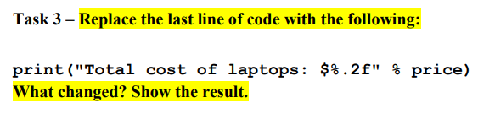

Answer

numLaptops = 7   
laptopCost = 599.50   
price = numLaptops * laptopCost   
print("Total cost of laptops: $%.2f" % price)

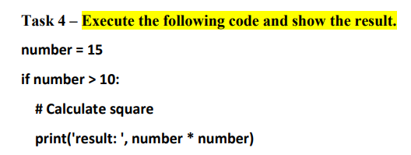

Answer

number = 15   
  
if number > 10:   
 print('result: ', number * number)

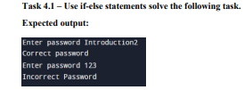

Answer

c = "Introduction2"  
e = input("Enter password: ")  
if e == c:  
 print("Correct password")  
else:  
 print("Incorrect Password")

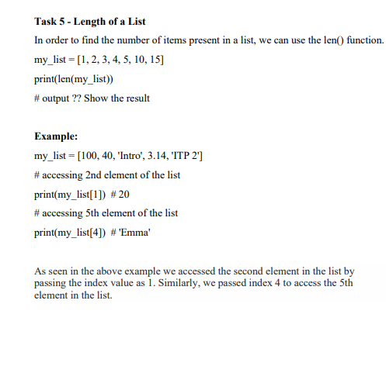

Answer

mylist = [1, 2, 3, 4, 5, 10, 15]  
print(len(mylist))  
  
mylist1 = [100, 40, 'Intro', 3.14, 'TTP 2']  
print(mylist1[1])  
print(mylist1[4])

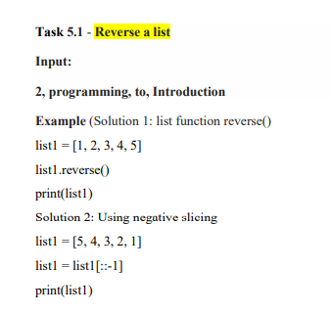

Answer

list1 = [1, 2, 3, 4, 5]   
list1.reverse()   
print(list1)   
  
   
list1 = [5, 4, 3, 2, 1]   
list1 = list1[::-1]   
print(list1)

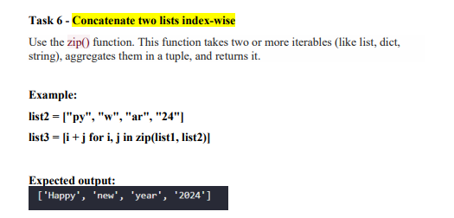

Answer

list1 = ["Happy", "new", "year", "2024"]   
list2 = ["py", "w", "ar", "24"]   
  
list3 = [i + j for i, j in zip(list1, list2)]   
print(list3)

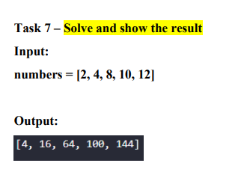

Answer

numbers = [2, 4, 8, 10, 12]   
result = [n**2 for n in numbers if n > 2]   
print(result)

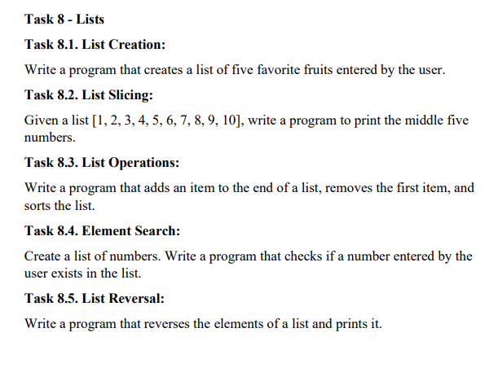

Answer

fruits = []   
for _ in range(5):   
 fruit = input("Enter a fruit: ")   
 fruits.append(fruit)   
print("Your favorite fruits are:", fruits)  
  
  
  
numbers = [1, 2, 3, 4, 5, 6, 7, 8, 9, 10]   
middle_five = numbers[2:7]   
print("Middle five numbers:", middle_five)  
  
  
  
  
my_list = [1, 2, 3, 4, 5]   
item_to_add = input("Enter an item to add: ")   
my_list.append(item_to_add)   
my_list.pop(0)   
my_list.sort()   
print("Updated list:", my_list)  
  
  
  
numbers = [1, 2, 3, 4, 5, 6, 7, 8, 9, 10]   
number_to_check = int(input("Enter a number to check: "))   
if number_to_check in numbers:   
 print("The number exists in the list.")   
else:   
 print("The number does not exist in the list.")  
   
   
   
 my_list = [1, 2, 3, 4, 5]   
my_list.reverse()   
print("Reversed list:", my_list)